Affymetrix Eukaryotic Sample and Array Processing Protocol

Protocol #: PA001_1

Version 1

Date: March 12, 2007

GEC

California Institute of Technology

Affymetrix Tech Support: 1-888-362-2447 Customer #126888
Fluidic Station Tech Support: 1-888-362-2447 Customer # FS1025
Bioanalyzer Tech Support: 1-800-227-9770

Quantification of RNA
Quantify total RNA sample on Nanodrop
Run ~50 ng of total RNA sample on Bioanalyzer

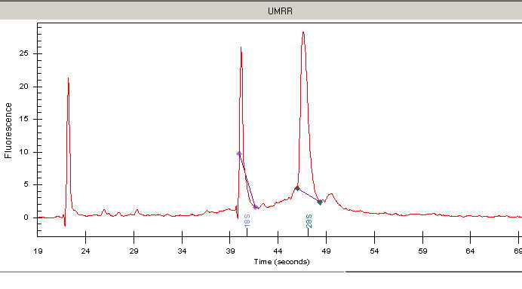

One Cycle cDNA Synthesis (reagents in blue boxes in -20)

Serial dilutions of Poly-A RNA Control stock in Poly-A Control Dilution Buffer
Poly-A Control Stock First Second Third
2 ul 2:40 1:50 1:50
The first dilution can be stored up to six weeks at -20°C

RNA/T7-Oligo(dT) Primer Mix
Sample RNA (2ug) < 8 ul
Poly-A RNA controls, 3rd dilution 2 ul
50uM T7-Oligo(dT) Primer 2 ul
RNase-free Water to 12 ul
Flick tubes to mix and centrifuge briefly

70°C, 10 min in thermal cycler
4°C, at least 2 min

First-Strand Master Mix
5X 1st Strand Reaction Mix 4 ul
0.1M DTT 2 ul
10mM dNTP 1 ul
Add 7ul to each RNA/T7 Primer mix for a final volume of 19 ul

42°C, 2 min in thermal cycler
Add 1 ul of Superscript II

42°C, one hour
4°C, at least 2 min

Second-Strand Master Mix- use thermal cycler.
RNase-free Water 91 ul
5X 2nd Strand Reaction Mix 30 ul
10mM dNTP 3 ul
DNA Ligase 1 ul
DNA Polymerase I 4 ul
RnaseH 1 ul
Add 130 ul Second-Strand master mix to each first-strand synthesis sample

16°C, 2 hours in thermal cycler * set a timer
Add 2 ul of T4 DNA polymerase

16°C, 5 min
Add 10 ul of 0.5M EDTA.
Proceed to cleanup of double-stranded cDNA; do not leave at 4°C for long periods of time.

Cleanup of Double-stranded cDNA (reagents on center shelves)
Transfer double-stranded cDNA to 1.7ml tube
Add 600 ul cDNA Binding Buffer
Vortex; mixture should stay yellow (if it turns orange or violet, add 10 ul of 3M NaOAc, pH5.0)
Add 500 ul of sample to the spin column
Centrifuge for one min at 8000 x g; discard flow-through
Add remaining mixture and centrifuge; discard flow-through
Transfer spin column into a new 2 ml collection tube
Add 750 ul cDNA Wash Buffer (make sure ethanol has been added to buffer)
Centrifuge for one min at 8000 x g; discard flow-through
Centrifuge at max speed for 5 min to allow complete drying of the membrane
Transfer spin column into a 1.7 ml tube
Pipet 14 ul of cDNA Elution Buffer directly onto the membrane
Incubate for one min at room temp; Centrifuge for one min at max speed to elute
Biotin Labeling of Antisense cRNA (reagents in blue boxes in -20)
IVT Reaction Master Mix
RNase-free Water 8 ul
10X IVT Labeling Buffer 4 ul
IVT Labeling NTP Mix 12 ul
IVT Labeling Enzyme Mix 4 ul
Add 28 ul IVT Reaction Master Mix to cleaned double-stranded cDNA

37°C, 16 hours in thermal cycler

Cleanup of Biotin-Labeled cRNA (reagents on center shelves)
Transfer IVT reaction into a 1.7 ml tube
Add 60 ul RNase-free water
Vortex for 3 sec
Add 350 ul IVT cRNA Binding Buffer
Vortex for 3 sec.
Add 250 ul ethanol to the lysate
Mix well by pipetting
Apply sample to spin column
Centrifuge at 8000 x g for 15 sec; discard flow-through
Add 500 ul of IVT cRNA Wash Buffer
Centrifuge at 8000 x g for 15 sec; discard flow-through
Add 500 ul of 80% ethanol
Centrifuge at 8000 x g for 15 sec; discard flow-through
Centrifuge at max speed for 5 min to allow complete drying of the membrane
Transfer spin column into a 1.7 ml non-stick tube
Pipet 11 ul of RNase-free water directly onto the membrane
Centrifuge for one min at max speed to elute
Pipet another 10 ul of RNase-free water directly onto the membrane
Centrifuge for one min at max speed to elute

Quantification of the cRNA
Dilute 1 ul of sample 1:5
Use NanoDrop to quantify the cRNA
Run ~500 ng of sample on Bioanalyzer
If the graph looks good in the bioanalyzer, proceed to cRNA fragmentation
Can store cRNA at -20°C or -80°C
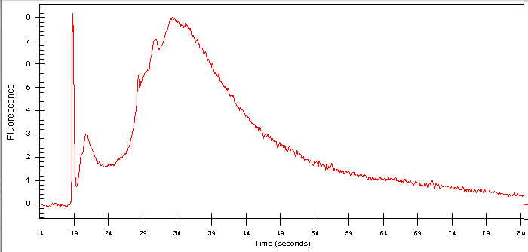

Fragmenting the cRNA (reagents in box with cleanup supplies on center shelves)
If sample has been frozen, use the Nanodrop to re-quantify prior to fragmentation
If the sample looks good, proceed to fragmentation

Fragmentation Reaction
cRNA(20 ug) < 32 ul
5X Fragmentation Buffer 8 ul
RNase-free water to 40 ul

94°C, 35 min in thermal cycler
Put on ice following incubation

Load 1ul of fragmentation reaction directly into the bioanalyzer

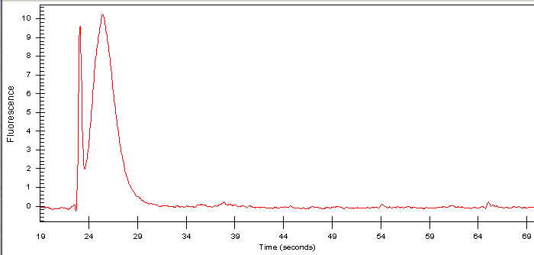

Hybridization for Probe Array (reagents in blue box in -20)
Preheat heat blocks to 65°C and 99°C
Turn on oven, set to 45°C
Equilibrate probe array to room temperature before use

Heat the 20X Euk. Hyb. Control at 65°C for 5 min in heat block

Hybridization Cocktail
Standard Array Midi Array Mini/Micro Array
Fragmented cRNA (15 ug) 30 ul (10 ug) 20 ul (5 ug) 10 ul
Control Oligo B2 5 ul 3.3 ul 1.7 ul
20X Euk.Hyb.Control 15 ul 10 ul 5 ul
Herring Sperm DNA 3 ul 2 ul 1 ul
BSA(50mg/ml) 3 ul 2 ul 1 ul
2X Hyb Buffer (fridge)150 ul 100 ul 50 ul
DMSO (hood) 30 ul 20 ul 10 ul
ddH2O 64 ul 42.5 ul 21.3 ul
300 ul 200 ul 100ul

99°C, 5 min in heat block

Wet the (room temperature) array by filling it through the lower septa with appropriate volume of 1X Hybridization Buffer. Insert another pipet tip in the upper septa for venting.
Standard Array 250 ul
Midi Array 180 ul
Mini/Micro Array 100 ul

Put probe array at 45°C for 10 min in oven
Move hyb cocktail to 45°C oven for 5 min

Spin hyb cocktail at max speed for 5 min to remove any insoluble material from the hyb mixture

Remove the buffer solution from the probe array cartridge and fill it with the hyb cocktail
Put back in the 45°C oven and set it to rotate at 45 rpm
Hybridize for 16 hours

Washing, Staining, and Scanning

(If the array pattern is not in the database, need to create it before adding a project. Go to affymetrix.com. Log in. Click on Support. Click on GeneChip Arrays. Look for the desired array pattern. Download the Library Files, save in the desktop. To add the probe array type in GCOS: Open the library files in the desktop. Open Full file. Look for the Setup.exe Application Type. Then follow the installation process. To upload the pattern in Resolver: Open the library files, copy and paste into a new folder the .cdf and .gin files. Open Resolver. Go to Admin. Create the new species in the New Species Database if it’s not under Species. Choose menu File -> Import ->Pattern. Select Affymetrix/GeneChip (CDF/CDL Files). File Name: browse for location of .cdf file. Pattern Name: type in the array name. Species Database: scroll down for the species just created in the database. Look for the feature size. Click on Import.)

Turn on the Fluidics Station
Change the intake deionized water reservoirs to their respective solutions Wash Buffers A & B (make sure there's at least 200ml of Wash Buffer A)

In the computer, click on the GeneChip Operating Software icon. Click on the Experiment icon. Create a project name (initials_ date). Choose the array genome used. Create an experiment name. Sample name and Sample type fields are the same as the experiment name. Click on Save. Do the same procedure for other samples. Click on the Fluidics icon. Click on Module 1. Choose Prime for the protocol. Then click on Run. Do the same procedure for the other samples. Priming the Fluidics Station will take about 10 min.

Prepare staining solution (reagents in white box in fridge)
Stains 1 & 3: SAPE Solution Mix (per sample)
2X Stain Buffer 600 ul
BSA 50 mg/ml 48 ul
SAPE 1 mg/ml 12 ul
ddH2O 540 ul
1200 ul
Vortex. Divide into 2 aliquots (600ul each)

Stain 2: Antibody Solution Mix (per sample)
2X Stain Buffer 300 ul
BSA 50 mg/ml 24 ul
Goat IgG Stock 10 mg/ml 6 ul
Biotinylated Ab 0.5 mg/ml 3.6 ul
ddH2O 266.4 ul
600 ul

Take probe array out of 45°C oven
Remove hyb cocktail from chip, and store in -20 freezer
Fill chip with Wash Buffer A

Insert the appropriate probe array into the designated module from the fluidics station (make sure the cartridge lever is in the eject position)
When finished, move the cartridge lever back to the engage position

In the computer, click on Module 1. Look for the experiment name that corresponds to the probe array in module 1. Select the appropriate protocol to run (will find this in the enclosed insert with the probe arrays). Then choose Run to begin the washing and staining.

Chip | Fluidics Protocol for FS400
Human Genome U133 Plus 2.0 | EukGE-WS2v5
Mouse Genome 430 2.0 | EukGE-WS2v5
Rat Genome 230 2.0 | Midi_euk2v3
Human Genome U133A 2.0 | Midi_euk2v3
Mouse Genome 430A 2.0 | Midi_euk2v3
Canine 2.0 | Midi_euk2v3
Drosophila Genome 2.0 | Midi_euk2v3
C. elegans Genome Array | EukGE-WS2v4

Follow the instructions on the LCD window on the fluidics station. When asked, change empty vial to stain solution 1 (SAPE soln). After about 45 min, change stain solution 1 to stain solution 2 (Ab soln). Then after 5-15 min, change Ab soln to stain solution 3 (SAPE soln).

Turn on scanner. Let it warm up for 10-15 min before using.

Remove probe array from the fluidics station module. Check the probe array window for air bubbles. If large bubbles are present, fill the array with Wash Buffer A manually using a micropipette.

Follow the instructions on the LCD window on the fluidics station. Remove stain solution vial from the fluidics station and replace it with an empty vial. The fluidics station automatically performs a Cleanout procedure. In the computer, choose Close; do not choose Stop. When the cleanout is finished, change intake wash buffer A & B reservoirs back to the ddH2O containers. Turn off station when finished.

In the computer, click on the Start scan button. Select the experiment name of the sample. Choose Load/Eject to insert the array in the scanner. Click on Start. Click Ok. The file name is “.DAT”.

After scanning, click on the Start button, choose Load/Eject to remove the probe array. Turn off the scanner.
Check the probe array image for B2 Oligo: alternating pattern on the border, checkerboard pattern at each corner, and the array name.

Data Acquisition
1. Create Report:
Run GeneChip Operating System program
On left side of screen, look for experiment name
Look for .CEL file nested under experiment name (click on + to left of name)
Right click .CEL
Choose Analyze
Click OK at suggested file name
Right click .CHP (nested under .CEL)
Choose Report
Print Report
Properties -> Advanced -> Finishing: 2 page per sheet
Compare values to make sure they pass the QC.
Check that they’re consistent between samples.
Background: average values should be between 40-60.
Number Present: should be between 25%-65%.
Number Marginal: should be below 2%.
Housekeeping Controls: for both Actin and GAPDH, the Sig(3’/5’) should be < 3 for one-cycle assay; higher ratios for two-cycle assay.
Spike Controls: for BioB, BioC, BioD, and Cre, should be present “P”
2. Create CAB File:
Run Data Transfer Tool program
Choose Transfer Out -> CAB Files
Choose Transfer Data Out
Choose Transfer GCOS Data
Change Project name to the correct project
Click on project name
Click Review
Click Start
CAB file will end up on desktop
There must be .EXP and .CEL files for each scan
Create new folder
Copy CAB contents into it
3. Get Barcodes:
Go to gec.bio.caltech.edu
Choose Caltech Extensions
Choose Chip Barcode Generator
Enter Username
Set Resolver Group as name of lab
Choose number of barcodes desired
Select and copy generated barcodes
4. Import Information into Resolver:
Log into Resolver
I. Choose Annotation -> Chips -> New
Chip Type: Affymetrix GeneChip
Pattern Name: search for correct species
Access Control: Public, GEC, lab name
(now is a good time to Duplicate to desired number of chips)
Chip Barcode: paste copied barcodes
Click Save and Close
II. Choose Annotation -> Preps -> New
Cells/Tissues: mRNA UNKNOWN
Prep Name = Prep Code: name of each sample, starting with your initials
Click Save and Close
III. Choose Annotation -> Intensity Hybs -> New
Access Control: Public, GEC, lab name
Chip Barcode: search for newly-created ones (under current date)
Prep Code: search for newly-created ones (type in intials)
will automatically fill in Hyb Name
Click Save and Close
IV. Choose menu File -> Import -> Scan -> Intensity
Select Affymetrix/GeneChip (CDF/CEL Files)
Scan Quality: Passed QC
Chip Barcode: search for newly-created ones
will automatically fill in Scan Name
File Name: browse for location of .CEL file (in the folder on the desktop created earlier)
Check to make sure File Name matches with Hyb!
Click Import
To check the scan queue, choose menu File -> Monitor
Affymetrix Reagent Preparation- Eukaryotic Sample

12X MES Stock Buffer (1 L)- 1.22M MES, 0.89M Na+
MES hydrate 64.61 g
MES Sodium Salt 193.3 g
Molecular Biology Grade Water 800 ml
*Mix and adjust volume to 1L
Check that the pH is between 6.5 to 6.7.
Filter through a 0.2 um filter in the cabinet by Vijaya's desk. Do not autoclave.
Store at 4°C and protect from light. Discard solution if yellow.

2X Hybridization Buffer (50 ml)- Final 1X is 100mM MES, 1M NA+, 20mM EDTA, 0.01% Tween-20
12X MES Stock Buffer (fridge) 8.3 ml
5M NaCl 17.7 ml
0.5M EDTA (far shelves) 4 ml
10% Tween-20 (far shelves) 0.1 ml (undiluted on middle shelves, brown bottle)
ddH2O 19.9 ml
*Store at 4°C and protect from light.

1X Hybridization Buffer
Dilute 2X Hybridization buffer with ddH2O in 1:2 dilution.
*Store at 4°C and protect from light.

Wash Buffer A: Non-Stringent Wash Buffer (1 L)- 6xSSPE, 0.01% Tween-20
20X SSPE (yellow label) 300 ml
10% Tween-20 (far shelves) 1 ml (undiluted on middle shelves, brown bottle)
ddH2O 699 ml
*Filter through a 0.2um filter in the cabinet by Vijaya's desk. Store at 4°C.

Wash Buffer B: Stringent Wash Buffer (1 L)- 100mM MES, 0.1M Na+, 0.01% Tween20
12X MES Stock Buffer 83.3 ml
5M NaCl 5.2 ml
10% Tween-20 1 ml
ddH2O 910.5 ml
*Filter through a 0.2 um filter.
Store at 4°C and protect from light.

2X Stain Buffer (250 ml)- Final 1X is 100mM MES, 1M Na+, 0.05% Tween-20
12X MES Stock Buffer 41.7 ml
5M NaCl 92.5 ml
10% Tween-20 2.5 ml
ddH2O 113.3 ml
*Filter through a 0.2um filter in the cabinet by Vijaya's desk.
Store at 4°C and protect from light.

Goat IgG Stock (5 ml)- 10 mg/ml (undiluted stock is in orange capped vial in freezer)
Resuspend 10 mg in 1 ml of 150mM NaCl
*Store at 4°C

Biotinylated Anti-Streptavidin (1 ml)- 0.5 mg/ml
Resuspend 0.5 mg in 1 ml of ddH2O. *Store at 4°C.

Regents Required:

Affymetrix:
- 900493 GeneChip® Expression 3' Amplification One-Cycle Target Labeling and
Control Reagents (includes 900433 GeneChip® Eukaryotic Poly-A RNA Control Kit; 900431 One-Cycle cDNA Synthesis Kit; 900449 IVT Labeling Kit; 900454 GeneChip® Expression 3' Amplification Reagents – Hybridization Controls; 900371 GeneChip® Sample Cleanup Module)

Invitrogen:
- 15561020 BOVINE SERUM ALBUMIN (BSA) 150 MG

- S866 STREPTAVIDIN, R-PHYCOERYT 1 ML

SIGMA:
- I5256-10MG GOAT IMMUNOGLOBULIN G (IGG) FROM SERUM 10mg

Fisher Scientific:
- PRD1811 Sperm, Herring, DNA, 10mg (in plastic bag on top shelf of freezer)

Vector Laboratories:
- BA-0500 Biotinylated Anti-Streptavidin 0.5 MG

Agilent Technologies:
- 5067-1511 Agilent RNA 6000 Nano Kit 2

